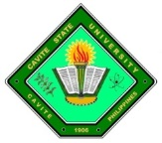
Republic of the Philippines
CAVITE STATE UNIVERSITY
Don Severino de las Alas Campus
Indang, Cavite

C E R T I F I C A T I O N

This is to certify that DARYLL JAMES SORIANO, IVAN G. CARAY, MARK ANTHONY CATAYLO, and JOMEL JOHN DOLLOSA, under the Bachelor of Science in Computer Science program, have successfully completed the software requirement of their study titled, “Management Information System for the College of Engineering and Information Technology, Cavite State University – Main Campus”. The researchers are hereby recommended for software evaluation this 8th day of May 2023.

ACE AMIEL E. MALICSI EZRA MARIE F. RAMOS
Thesis Adviser Technical Critic

